HW 1
Q1
Date Byte of PC memory
1970 262144
1988 2097152
1991 16777216
1996 2.68E+08
1998 1.07E+09
2004 4.29E+09
2009 8.59E+09
2014 1.72E+10

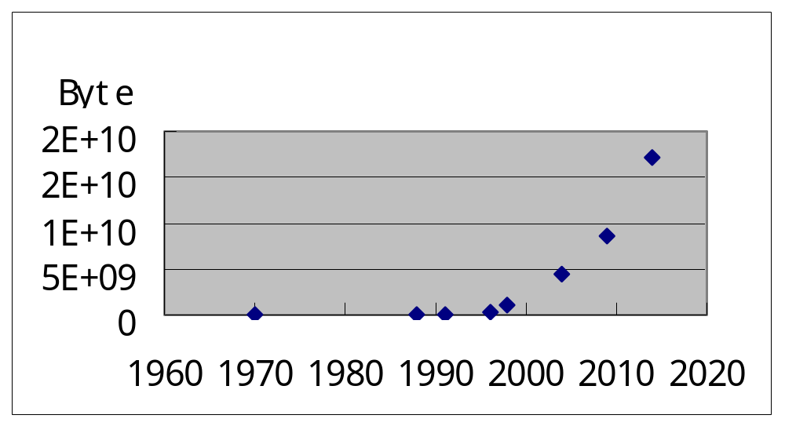
Q2

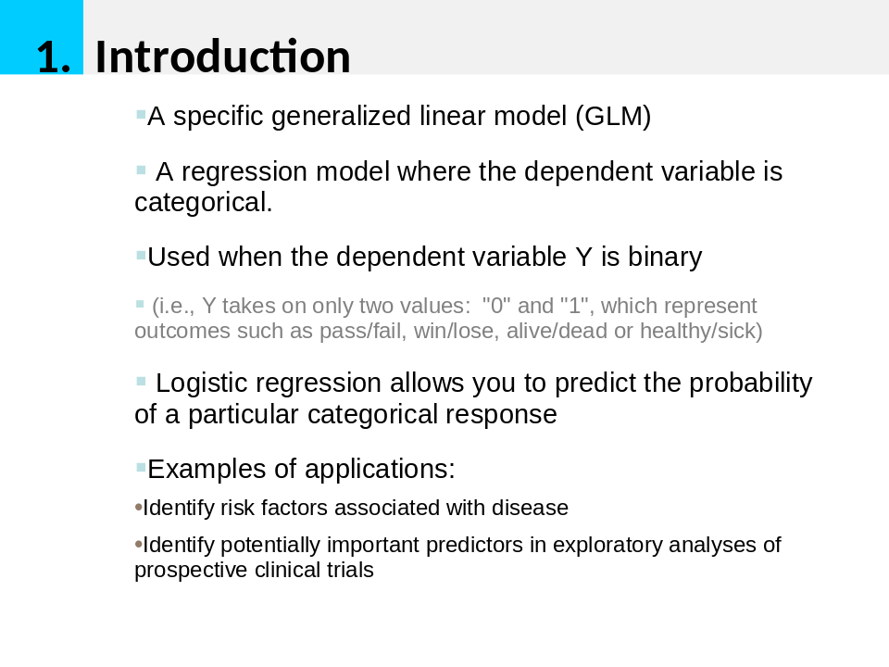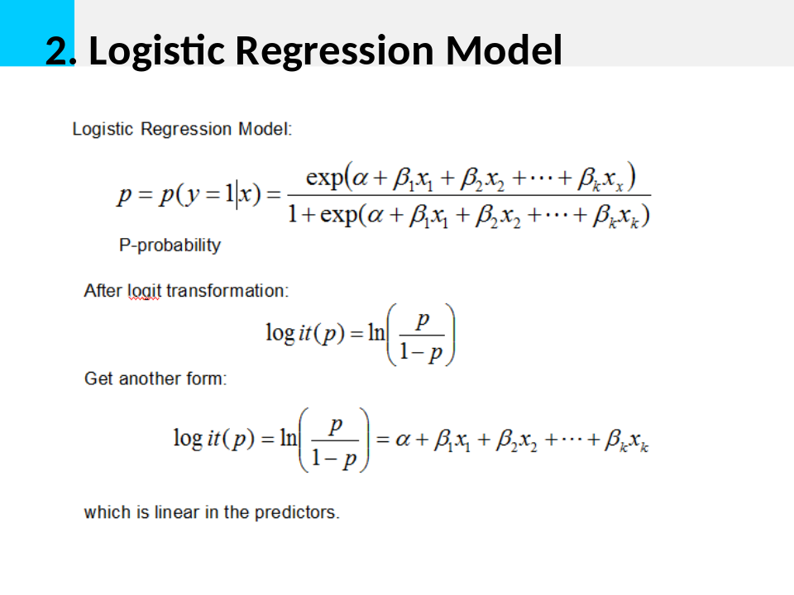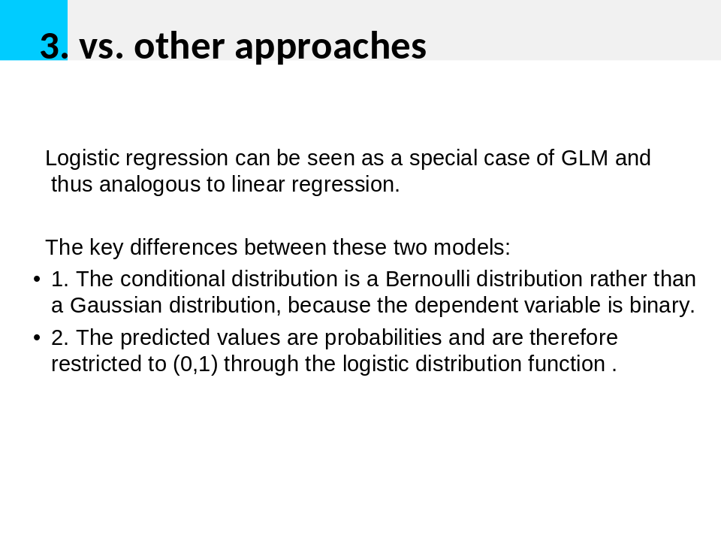

HW2
Q1
x = c (1970,1988,1991,1996,1998,2004,2009,2014)
y =
c(262144,2097152,16777216,268435456,1073741824,4294967296,8589934592,17179869184)
plot(x,y)

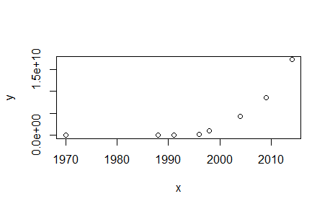

Q2
Memory.csv
year | Byte
1970 | 262144
1971 | 262144
1972 | 262144
1973 | 262144
1974 | 262144
1975 | 262144
1976 | 262144
1977 | 262144
1978 | 262144
1979 | 262144
1980 | 262144
1981 | 262144
1982 | 262144
1988 | 2097152
1989 | 2097152
1990 | 2097152
1991 | 16777216
1992 | 16777216
1993 | 16777216
1994 | 16777216
1995 | 16777216
1996 | 2.68E+08
1997 | 2.68E+08
1998 | 1.07E+09
1999 | 1.07E+09
2000 | 1.07E+09
2004 | 4.29E+09
2009 | 8.59E+09
2014 | 1.72E+10

memory.df = read.csv("memory.csv",header = TRUE)
plot(memory.df$Byte~memory.df$year)
splines.reg.l1 = smooth.spline(x = memory.df$year, y = memory.df$Byte, spar = 0.2)
splines.reg.l2 = smooth.spline(x = memory.df$year, y = memory.df$Byte, spar = 1)
splines.reg.l3= smooth.spline(x = memory.df$year, y = memory.df$Byte, spar = 2)
lines(splines.reg.l1, col = "red", lwd = 2)
lines(splines.reg.l2, col = "green", lwd = 2)
lines(splines.reg.l3, col = "blue", lwd = 2)
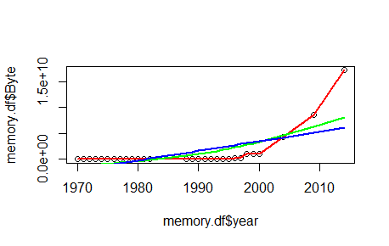

Q3
> x = 3
> lambda = 2
> dpois(x,lambda) # probability mass function
[1] 0.180447
>
> x = 0
> lambda = 5
> dpois(x,lambda) # probability mass function
[1] 0.006737947
HW 3
Q1
# install stuff for hash calculation
install.packages("digest", repos='http://cran.us.r-project.org')
# call the library doing the hashes
library("digest")
# now do the hash code calculation
digest("I learn a lot from this class when I am proper listening to the professor","sha256")
digest("I do not learn a lot from this class when I am absent and playing on my Iphone","sha256")

> digest("I learn a lot from this class when I am proper listening to the professor","sha256")
[1] "c16700de5a5c1961e279135f2be7dcf9c187cb6b21ac8032308c715e1ce9964c"
> digest("I do not learn a lot from this class when I am absent and playing on my Iphone","sha256")
[1] "2533d529768409d1c09d50451d9125fdbaa6e5fd4efdeb45c04e3c68bcb3a63e"

Q2

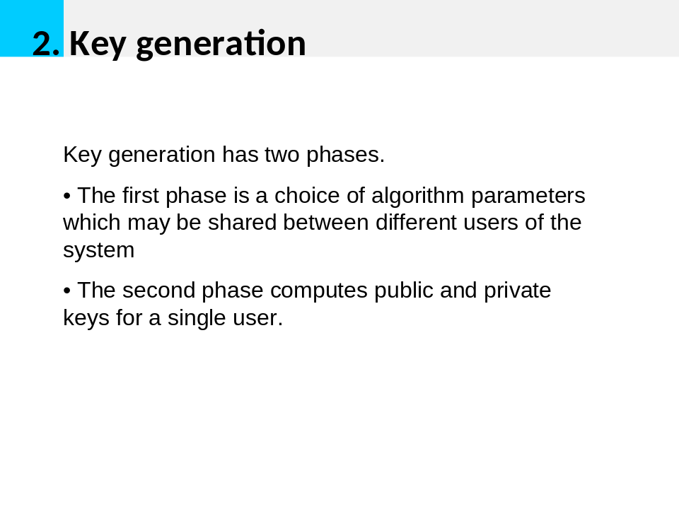
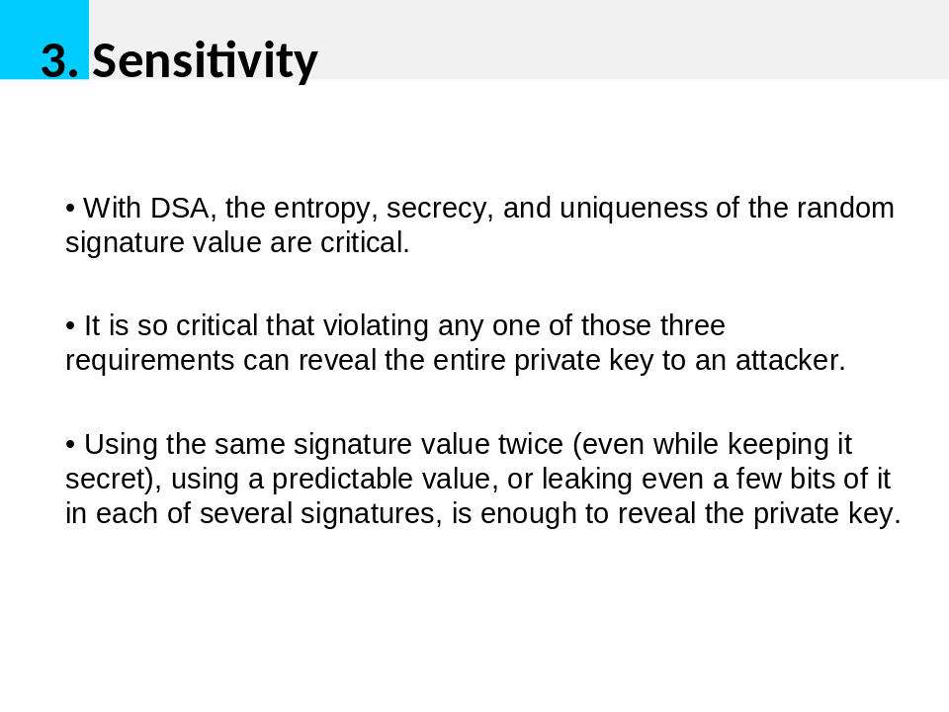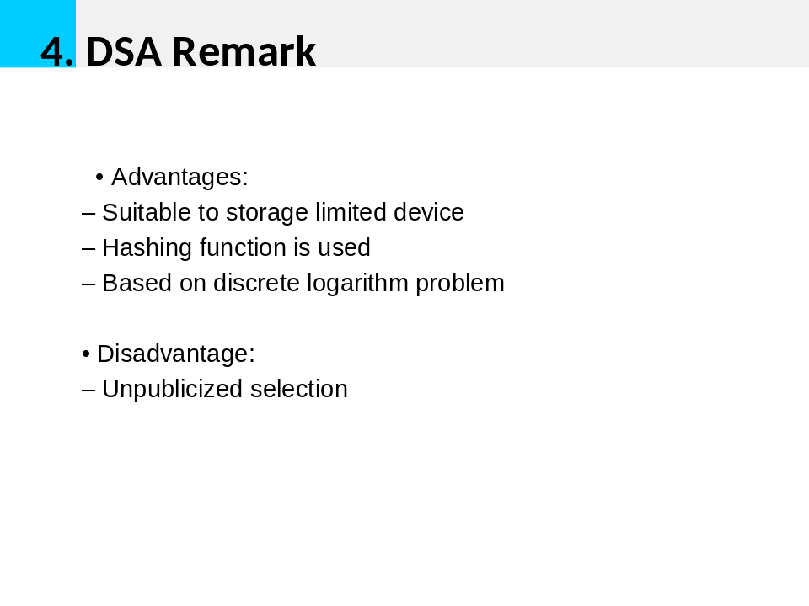
Q3
#20171017 JSON input from CRIX , trial done in XMNinstall.packages("rjson",repos="http://cran.us.r-project.org")
library("rjson")
=================
# create and save in txt（save as "try.json" ; "all types" ;）
{
"ID":["001","002","003","004","005","006","007","008" ],
"Salary":["600","500","600","700","800","500","600","70" ],

"StartDate":["1/1/2016","9/23/2017","11/15/2017","5/11/2017,"3/27/2017","5/21/2017",
"7/30/2016","6/17/2016"],
}
====================

install.packages("rjson")
# Load the package required to read JSON files.
library("rjson")
# Give the input file name to the function.
result <- fromJSON(file = “try.json")
# Print the result.
print(result)

Q4
#20171017 JSON input from CRIX , trial done in XMNinstall.packages("rjson",repos="http://cran.us.r-project.org")
library("rjson")
json_file = "http://crix.hu-berlin.de/data/crix.json"
json_data = fromJSON(file=json_file)
crix_data_frame = as.data.frame(json_data)
x = crix_data_frame
n = dim(x)
a = seq(1,n[2],2)
b = seq(2,n[2],2)
date = t(x[1,a])
price = t(x[1,b])
plot(price)
dim(price)
ts.plot(price)
ret = diff( log(price) )
ts.plot( ret )
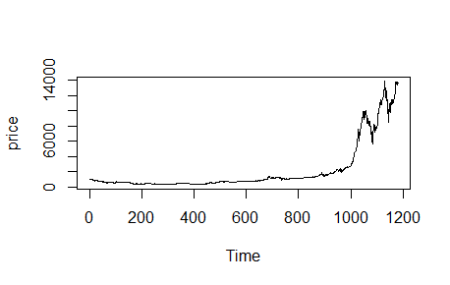

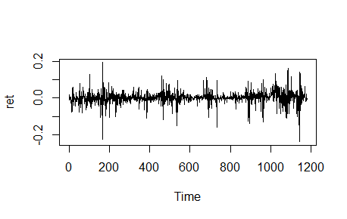

HW 4
Q1
Q1
#20171017 JSON input from CRIX , trial done in XMN

install.packages("rjson",repos="http://cran.us.r-project.org")
library("rjson")
json_file = "http://crix.hu-berlin.de/data/crix.json"
json_data = fromJSON(file=json_file)

crix_data_frame = as.data.frame(json_data)
x = crix_data_frame
n = dim(x)
a = seq(1,n[2],2)
b = seq(2,n[2],2)

#figure 3 : The daily value of CRIX
date = t(x[1,a])
price = t(x[1,b])
plot(price)
#figure 4 : The log returns of CRIX index
dim(price)
ts.plot(price)
ret = diff( log(price) )
ts.plot( ret )
#figure 5 : Histogram
hist(ret, col = "grey", breaks = 20, freq = FALSE, ylim = c(0, 25), xlab = NA)
lines(density(ret), lwd = 2)
mu = mean(ret)l,
sigma = sd(ret)
x = seq(-4, 4, length = 100)
curve(dnorm(x, mean = mean(ret), sd = sd(ret)), add = TRUE, col = "darkblue", lwd = 2)
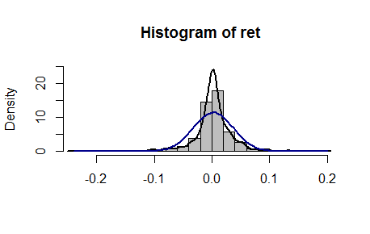
#figure 6 : QQ plot
qqnorm(ret)
qqline(ret, col = "blue", lwd = 3)
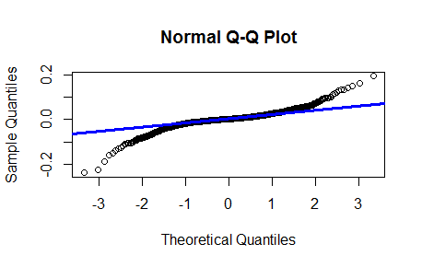
Q2
rm(list = ls(all = TRUE))
graphics.off()

# install and load packages
libraries = c("zoo", "tseries")
lapply(libraries, function(x) if (!(x %in% installed.packages())) {
install.packages(x)
})
lapply(libraries, library, quietly = TRUE, character.only = TRUE)

#RET
("rjson",repos="http://cran.us.r-project.org")
library("rjson")
json_file = "http://crix.hu-berlin.de/data/crix.json"
json_data = fromJSON(file=json_file)
crix_data_frame = as.data.frame(json_data)
x = crix_data_frame
n = dim(x)
a = seq(1,n[2],2)
b = seq(2,n[2],2)
date = t(x[1,a])
price = t(x[1,b])
dim(price)
ret = diff( log(price) )

# d order
Box.test(ret, type = "Ljung-Box", lag = 20)

# stationary test
adf.test(ret, alternative = "stationary")
kpss.test(ret, null = "Trend")

par(mfrow = c(1, 2))
# acf plot
autocorr = acf(ret, lag.max = 20, ylab = "Sample Autocorrelation", main = NA,
lwd = 2, ylim = c(-0.3, 1))

# LB test of linear dependence
print(cbind(autocorr$lag, autocorr$acf))
Box.test(ret, type = "Ljung-Box", lag = 1, fitdf = 0)
Box.test(autocorr$acf, type = "Ljung-Box")

# plot of pacf
autopcorr = pacf(ret, lag.max = 20, ylab = "Sample Partial Autocorrelation",
main = NA, ylim = c(-0.3, 0.3), lwd = 2)
print(cbind(autopcorr$lag, autopcorr$acf))
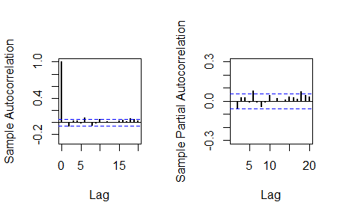
# arima model
par(mfrow = c(1, 1))
auto.arima(ret)
fit1 = arima(ret, order = c(1, 0, 1))
tsdiag(fit1)
Box.test(fit1$residuals, lag = 1)

# aic
aic = matrix(NA, 6, 6)
for (p in 0:4) {
for (q in 0:3) {
a.p.q = arima(ret, order = c(p, 0, q))
aic.p.q = a.p.q$aic
aic[p + 1, q + 1] = aic.p.q
}
}
aic

# bic
bic = matrix(NA, 6, 6)
for (p in 0:4) {
for (q in 0:3) {
b.p.q = arima(ret, order = c(p, 0, q))
bic.p.q = AIC(b.p.q, k = log(length(ret)))
bic[p + 1, q + 1] = bic.p.q
}
}
bic

# select p and q order of ARIMA model
fit4 = arima(ret, order = c(2, 0, 3))
tsdiag(fit4)
Box.test(fit4$residuals, lag = 1)

fitr4 = arima(ret, order = c(2, 1, 3))
tsdiag(fitr4)
Box.test(fitr4$residuals, lag = 1)

# to conclude, 202 is better than 213
fit202 = arima(ret, order = c(2, 0, 2))
tsdiag(fit202)
tsdiag(fit4)
tsdiag(fitr4)

AIC(fit202, k = log(length(ret)))
AIC(fit4, k = log(length(ret)))
AIC(fitr4, k = log(length(ret)))
fit202$aic
fit4$aic
fitr4$aic

# arima202 predict
fit202 = arima(ret, order = c(2, 0, 2))
crpre = predict(fit202, n.ahead = 30)

dates = seq(as.Date("02/08/2014", format = "%d/%m/%Y"), by = "days", length = length(ret))

plot(ret, type = "l", xlim = c(0, 644), ylab = "log return", xlab = "days",
lwd = 1.5)
lines(crpre$pred, col = "red", lwd = 3)
lines(crpre$pred + 2 * crpre$se, col = "red", lty = 3, lwd = 3)
lines(crpre$pred - 2 * crpre$se, col = "red", lty = 3, lwd = 3)
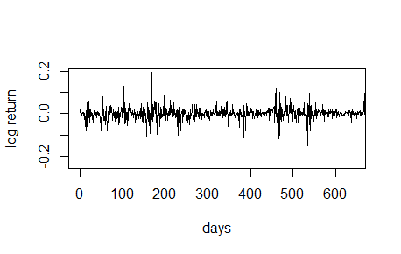
Q3
rm(list = ls(all = TRUE))
graphics.off()

# install and load packages
libraries = c("FinTS", "tseries")
lapply(libraries, function(x) if (!(x %in% installed.packages())) {
install.packages(x)
})
lapply(libraries, library, quietly = TRUE, character.only = TRUE)

# plot of crix return
ret = diff(log(crx$Pr))
Dare = factor(date1[-1])
retts = data.frame(Dare, ret)

# comparison of different crix returns
par(mfrow = c(2, 2))
plot(crx$Da, crx$Pr, type = "o")
lines(crx$Pr)
plot(crx$Da, log(crx$Pr), type = "o")
lines(log(crx$Pr))
plot(retts$Dare, diff(crx$Pr), type = "o")
lines(diff(crx$Pr))
plot(retts$Dare, retts$ret, type = "o")
lines(retts$ret)

# ARIMAfit <- auto.arima(ret, approximation=FALSE,trace=FALSE)
# summary(ARIMAfit)

# arima202 predict
fit202 = arima(ret, order = c(2, 0, 2))

# vola cluster
par(mfrow = c(1, 1))
res = fit202$residuals
res2 = fit202$residuals^2
tsres202 = data.frame(Dare, res2)
plot(tsres202$Dare, tsres202$res2, type = "o", ylab = NA)
lines(tsres202$res2)

par(mfrow = c(1, 2))
# plot(res2, ylab='Squared residuals', main=NA)
acfres2 = acf(res2, main = NA, lag.max = 20, ylab = "Sample Autocorrelation",
lwd = 2)
pacfres2 = pacf(res2, lag.max = 20, ylab = "Sample Partial Autocorrelation",
lwd = 2, main = NA)

# arch effect
res = fit202$residuals
ArchTest(res) #library FinTS
Box.test(res2, type = "Ljung-Box")
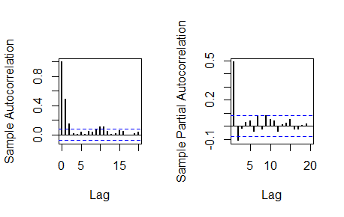

HW 5
Q1&Q2
rm(list = ls())
library(RCurl)
library(XML)
library(bitops)
library(stringr)
url=paste(c("http://publicliterature.org/pdf/2ws1610.pdf","http://publicliterature.org/pdf/2ws2410.pdf","http://publicliterature.org/pdf/2ws3310.pdf") )
abs=lapply(url, FUN = function(x) htmlParse(x, encoding = "Latin-1"))
clean_txt = function(x) {
cleantxt = xpathApply(x, "//body//text()
[not(ancestor :: script)][ not(ancestor :: style)]
[not(ancestor :: noscript)] " ,xmlValue)
cleantxt = paste(cleantxt, collapse="\n")
cleantxt = str_replace_all(cleantxt, "\n", " ")
cleantxt = str_replace_all(cleantxt, "\r", "")
cleantxt = str_replace_all(cleantxt, "\t", "")
cleantxt = str_replace_all(cleantxt, "<br>", "")
return(cleantxt)
}
cleantxt = lapply(abs,clean_txt)
vec_abs = unlist(cleantxt)
vec_abs
library(tm)
library(SnowballC)
abs = Corpus(VectorSource(vec_abs))
abs_dtm = DocumentTermMatrix(abs, control = list(
stemming = TRUE, stopwords = TRUE, minWordLength = 3,
removeNumbers = TRUE, removePunctuation = TRUE))
dim(abs_dtm)
inspect(abs_dtm)
#Find the words that occur more than 5 times
findFreqTerms(abs_dtm, 5)
#Remove sparse terms
removeSparseTerms(abs_dtm, 0.5)
inspect(removeSparseTerms(abs_dtm, 0.5))
library(ggplot2)
library(wordcloud)
freq = colSums(as.matrix(abs_dtm))
wf = data.frame(word=names(freq), freq=freq)
plot = ggplot(subset(wf, freq>100), aes(word, freq))
plot = plot + geom_bar(stat="identity")
plot = plot + theme(axis.text.x=element_text(angle=45, hjust=1))
plot
freq = colSums(as.matrix(abs_dtm))
dark2 = brewer.pal(8, "Dark2")
wordcloud(names(freq), freq, max.words=200, rot.per=0.1, colors=dark2)
dev.off()


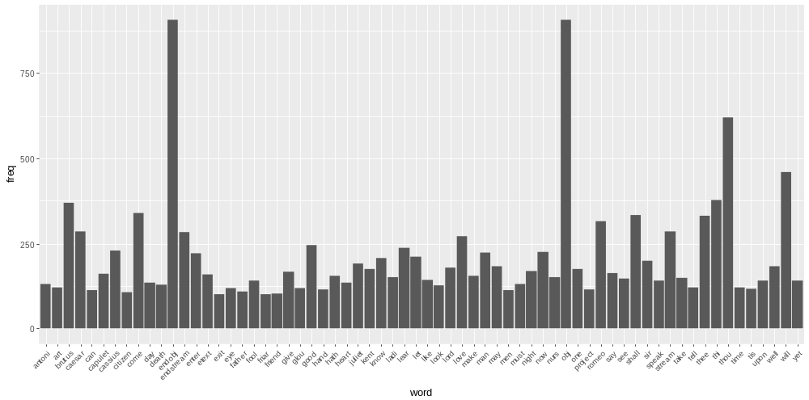
hist(freq, col = "grey", breaks = 20,ylim = c(0, 5000), xlab = "freq of words")

